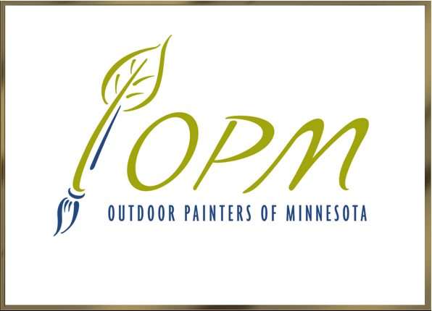
Allison Eklund, President
Sallie Malmstrom, Secretary
Peter Mathews, Treasurer
Mary Jo Ellis, Membership
Susan Estill, Paint-Outs
Rich Myers, Web Site

OPM Monthly Meeting Agenda

Saturday, May 6, 2017
12:30 p.m. | Ramsey County Library—Shoreview

**ELECTION** Propose election by acclamation (white ballot) of candidates, President: Allison Eklund, Secretary: Sallie Malmsstrom & Treasurer: Mark Ellis

Secretary’s Report (Sallie Malmstrom)
- Approval of March 11 Minutes
President’s Report (Allison Eklund)
- PACE 2017: Networking, ideas for development & member growth
- Arts@MSP continuing exhibit proposal declined, Wayzata Art Experience canceled, and no FrameWorks fall salon. Application pending for 2018 exhibit at Banfill-Locke CFA.
- Loring Park Art Festival is on, with free admission/painting/exhibits for painters.
  - Need SignUp ASAP for painters, set-up, take-down, and time slots in tent.
  - Need Advance Paint-Outs scheduled the week or two before, invitations to paint in advance to seed tent with LP paintings.
- Major Exhibits: Como June 11 through Labor Day; Hennepin History Museum July 15 through September 17; and River Falls Library November 11 through December 15.
Treasurer’s Report (Mark Ellis)

Membership Report (Mary Jo Ellis): We have 131 members. 33 are new and 98 are renewals.

Paint-Outs Report (Susan Estill)

Old Business
- Paint-Out and exhibit with 50% commission, 100% price markup at UMN Landscape Arboretum: Peter & Allison will meet with Wendy DePaolis
New Business
Approvals needed:
- Hennepin History Museum exhibit: 12 people, 2 paintings each, plein air or 1 studio with field study, and July 21 commitment
NEXT MEETING: DATE, TIME & PLACE.
May 6, 2017 Monthly Meeting

Sign-In Sheet

Name | Email Address (to circulate minutes)
Allison Eklund | allison@eklund-law.com

