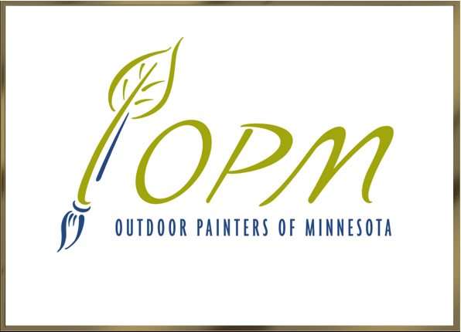
Allison Eklund, President
Sallie Malmstrom, Secretary
Peter Mathews, Treasurer
Mary Jo Ellis, Membership
Susan Estill, Paint-Outs
Rich Myers, Web Site

OPM Monthly Meeting Agenda

Saturday, March 11, 2017
10:00 a.m. | Mia

Introductions and Sign-in

Secretary’s Report (Sallie Malmstrom)
- Approval of January 19 Minutes
President’s Report (Allison Eklund)
- January 14 Planning Meeting report
- Member participation survey
- Richard Abraham workshop + exhibit report
- Developments & Upcoming Events: Black Hills Road Trip canceled for May; Mary Pettis workshop + paint-out April 1, Spring Salon reception April 6, Allison & Sallie to PACE 2017 in San Diego, Plein Air Competition panel at May 6 meeting. Bob Upton coming, promoting his show & opening reception 6pm May 20 at FrameWorks.

Treasurer’s Report (Peter Mathews)

Membership Report (Mary Jo Ellis)

Paint-Outs Report (Susan Estill)

Old Business

New Business
Approvals needed:
- October paint-out and November Exhibit at Public Library in River Falls, WI
- Paint-Out and exhibit with 50% commission, 100% price markup at UMN Landscape Arboretum
- Greg Lecker proposes hosting 4 quarterly paint-outs at Banfill-Locke CFA, (April, July, October, April) with OPM submitting exhibit proposal by March 15 to hang show of our plein air paintings for May 2018
- Approvals to participate in June WAE and July LPAF require Volunteers to help coordinate
- Discussion of criteria for partnership with arts organization on nature preserve as permanent home for OPM
Nominations for May Election of Directors

NEXT MEETING: May 6, 2017, **TIME & PLACE**.
March 11, 2017 Monthly Meeting

Sign-In Sheet

Name | Email Address (to circulate minutes)

